**Elemente avansate de baze de date**

Inchirieri DVD-uri

**Groza Teodora**

**Informatica Economica, anul 3, grupa 3**

**Anul universitar 2020-2023**

# Scenariu

Diagrama Entitate – Relaţia surprinde activitatea din cadrul unui magazin de filme ce ofera DVD-uri, CD-uri sau jocuri video de inchiriat sau cumparat. Acestea sunt clasificate dupa categorie, limba sau artisti. Acestea sunt receptionate de catre casierii de pe tura, care se afla sub supravegherea managerului de resurse umane. În cadrul magazinului există câteva categorii de produse: DVD-uri, CD-uri si jocuri video, putându-se extinde pe viitor producţia. Produsele sunt inventariate in functie de data inchirierii sau cumpararii, iar apoi sunt clasificate ca produse vandute sau produse inchiriate. Produsele au trei tipuri de clasament: dupa gen, dupa limba sau dupa artist. La procesarea marfii, fiecarui produs ii este calculat un cost in functie de numarul de bucati si de pretul pe bucata. Angajatii de pe tura sunt responsabili de procesarea marfii si de facturarea acesteia, asadar angajatii cu mai multa experienta sunt de asteptat sa lucreze cand se asteapta livrarea marfii. Dupa achizitionarea unui produs, clientul este nevoit sa lase datele de contact, pentru a putea fi contactat in cazul intarzierii returnarii unui produs.

Printre angajatii se afla si managerii, cu departamentele respective, acestia fiind mai putin implicati in procesele zilnice de inchiriere, returnare, cumparare de produse. Programul magazinului este de 14 ore, acesta fiind deschis intre orele 8:00 si 22:00.

**Schema bazei de date**

|  |  |  |  |
| --- | --- | --- | --- |
| Employees | | | |
| Key | Optionality | Name | |
| PK | * | Id | |
|  | * | Name | |
| Firstname | Lastname |
|  | * | Date_of_birth | |
|  | ° | Date_of_employment | |
|  | ° | Contract_nr | |
|  | ° | Salary | |
|  | ° | Working_hours | |
|  | ° | Experience | |
|  | ° | Job | |
| Department | Post |
|  | ° | Supervisor | |

|  |  |  |  |  |  |
| --- | --- | --- | --- | --- | --- |
| Products | | | | | |
| Key | Optionality | Name | | | |
| PK | * | Id | | | |
|  | * | Title | | | |
|  | * | Type | | | |
|  | * | Genre | | | |
|  | * | Language | | | |
| Origine | | Subtitles | |
|  | * | Artists | | | |
| Firstname | | Lastname | |
|  | * | Inventory | | | |
| Date | State | | Price |

|  |  |  |  |  |  |  |  |
| --- | --- | --- | --- | --- | --- | --- | --- |
| Clients | | | | | | | |
| Key | Optionality | Name | | | | | |
| PK | * | Id | | | | | |
|  | * | Name | | | | | |
| Firstname | | | Lastname | | |
|  | * | Phone | | | | | |
|  | * | Email | | | | | |
|  | * | Address | | | | | |
| County | City | Street | Number | Apartment | Postal_code |

**Creare colectii**

db.createCollection(“clients”)

db.createCollection(“products”)

db.createCollection(“employees”)

Popularea datelor

db.products.insertMany(

{title:"Toy Story", type:"DVD", genre:["animation", "comedy", "family"], language:{origine:"english", subtitles:"romanian", dubbed:"romanian"}, artists:[{firstname:"Tom", lastname:"Hanks"}, {firstname:"Nathan", lastname:"Lane"}], inventary:{date:"19-ian-2017", state:"borrowed", returned:"23-ian-2017"}},

{title:"The Witcher", type:"video game", genre:["adventure", "action", "fantasy"], language:{origine:"english", subtitles:"english"}, artists:[{firstname:"Doug", lastname:"Cockle"}, {firstname:"Denise", lastname:"Gough"}], inventary:{date:"14-iul-2018", state:"purchased", price:"350"}},

{title:"Jubilee", type:"CD", genre:["alternative pop", "indie pop"], language:"english", artists:"Japanese Breakfast",content:["Be Sweet", "Posing in Bondage", "Savage Good Boy", "Paprika"], inventary:{date:"07-feb-2021", state:"purchased", price:"90"}},

{title:"Kimetsu no Yaiba", type:"DVD", genre:["adventure", "animation", "fantasy"], language:{origine:"japanese", subtitles:"romanian", dubbed:"english"}, artists:[{firstname:"Takahiro", lastname:"Sakurai"}, {firstname:"Natsuki", lastname:"Hanae"}], inventary:{date:"13-iun-2015", state:"borrowed",returned:"29-iun-2015"}},

{title:"Pirates of the Caribbean", type:"DVD", genre:["adventure", "action", "fantasy"], language:{origine:"english", subtitles:"romanian"}, artists:[{firstname:"Johnny", lastname:"Depp"}, {firstname:"Keira", lastname:"Knightley"}, {firstname:"Orlando", lastname:"Bloom"}], inventary:{date:"01-nov-2016", state:"purchased", price:"369"}}, {title:"Scream", type:"DVD", genre:["mystery", "horror", "thriller"], language:{origine:"english", subtitles:"romanian"}, artists:[{firstname:"Neve", lastname:"Campbell"}, {firstname:"Courteney", lastname:"Cox"}, {firstname:"David", lastname:"Arquette"}], inventary:{date:"05-dec-2019", state:"borrowed", returned:"10-dec-2019"}},

{title:"Dark Spell", type:"DVD", genre:["fanatsy", "horror", "romance"], language:{origine:"russian", subtitles:"english"}, artists:[{firstname:"Yana", lastname:"Enzhaeva"}, {firstname:"Konstantin", lastname:"Beloshapka"}, {firstname:"Ilya", lastname:"Ermolov"}], inventary:{date:"11-mar-2018", state:"purchased", price:"290"}})

db.employees.insertMany(

{name:{firstname:"Alin", lastname:"Petrescu"}, date_of_birth:"15-iun-1978", date_of_employment:"12-mar-2010", contract_nr:"12031", salary:"2400", working_hours:"8", experience:"4 years", job:{department:"client services", post:"cashier"}, supervisor:"human resources"},

{name:{firstname:"Ana-Maria", lastname:"Filip"}, date_of_birth:"03-mai-1998", date_of_employment:"01-apr-2017", contract_nr:"12032", salary:"1800", working_hours:"6", experience:"2 years", job:{department:"client services", post:"cashier"}, supervisor:"human resources"},

{name:{firstname:"Matei", lastname:"Muresan"}, date_of_birth:"17-nov-1984", date_of_employment:"06-iul-2005", contract_nr:"11020", salary:"3000", working_hours:"8", experience:"7 years", job:{department:"human resources", post:"manager"}, supervisor:"director"},

{name:{firstname:"Mihaela", lastname:"Ursu"}, date_of_birth:"06-iul-1989", date_of_employment:"19-aug-2019", contract_nr:"12033", salary:"1200", working_hours:"4", experience:"none", job:{department:"client services", post:"cashier"}, supervisor:"human resources"},

{name:{firstname:"Ioana", lastname:"Marcu"}, date_of_birth:"24-mar-1975", date_of_employment:"22-nov-2015", contract_nr:"10043", salary:"3200", working_hours:"8", experience:"5 years", job:{department:"finance", post:"manager"}, supervisor:"director"},

{name:{firstname:"Vlad", lastname:"Susca"}, date_of_birth:"28-feb-1981", date_of_employment:"10-oct-2013", contract_nr:"12010", salary:"3000", working_hours:"8", experience:"3 years", job:{department:"quality management", post:"manager"}, supervisor:"director"},

{name:{firstname:"Carmen", lastname:"Marian"}, date_of_birth:"07-sep-1999", date_of_employment:"19-mai-2019", contract_nr:"12040", salary:"1200", working_hours:"4", experience:"2 years", job:{department:"client services", post:"cashier"}, supervisor:"human resources"},

{name:{firstname:"Alexandru", lastname:"Morar"}, date_of_birth:"13-oct-1968", date_of_employment:"11-mar-2000", contract_nr:"none", salary:"4000", working_hours:"8+", experience:"5 years", job:{post:"director"}, supervisor:"none"})

db.clients.insertMany(

{name:{firstname:"Adraian", lastname:"Popescu"}, phone:"0756234857", email:"popescu.adrian@yahoo.com", adress:{county:"Cluj", city:"Cluj-Napoca", street:"Plopilor", number:"7", apartment:"43", postal_code:"432156"}},

{name:{firstname:"Maria", lastname:"Pop"}, phone:"0745736477", email:"pop.maria@yahoo.com", adress:{county:"Cluj", city:"Cluj-Napoca", street:"Constantin Brancusi", number:"27", apartment:"10", postal_code:"400126"}},

{name:{firstname:"Marcel", lastname:"Cristea"}, phone:"0734657212", email:"cristea_marcel11@gmail.com", adress:{county:"Satu Mare", city:"Satu Mare", street:"Claiurilor", number:"13", apartment:"17", postal_code:"409896"}},

{name:{firstname:"Ileana", lastname:"Andrescu"}, phone:"0723485766", email:"andrescu.ileana@gmail.com", adress:{county:"Alba", city:"Alba Iulia", street:"Lebadei", number:"39", apartment:"11", postal_code:"411006"}},

{name:{firstname:"Cristina", lastname:"Marin"}, phone:"0786749586", email:"marin.cristina@yahoo.com", adress:{county:"Ilfov", city:"Bucuresti", street:"Florilor", number:"3", apartment:"22", postal_code:"556123"}},

{name:{firstname:"Andreea", lastname:"Coroian"}, phone:"0765473457", email:"andreea_coroian@yahoo.com", adress:{county:"Maramures", city:"Baia Mare", street:"Albac", number:"1", apartment:"1", postal_code:"430026"}},

{name:{firstname:"Cristina", lastname:"Macies"}, phone:"0758736453", email:"macies.cristina101@gmail.com", adress:{county:"Cluj", city:"Turda", street:"Malinului", number:"27", apartment:"4", postal_code:"430016"}},

{name:{firstname:"Alex", lastname:"Sorin"}, phone:"0733465766", email:"sorinalex00@yahoo.com", adress:{county:"Arad", city:"Arad", street:"Alexandru Voievod", number:"10", apartment:"34", postal_code:"330156"}}

**Stergere**

db.clients.deleteOne({_id: ObjectId(“63c1950aa715f68184203d15”)})

**Actualizare**

db.products.updateOne({_id: ObjectId(“63c04da3a715f68184203cfd”)}, {$set: {language: {origine: “english”, dubbed: “spanish”}}})

**Introducerea a doua documente**

db.products.insertOne({name: "printed t-shirt", design:{print: "customized", image: "brought by the client"}, size: "L", color: "black", shirt_price: "30", print_price: "15", print_surface:{front: "yes", back: "no"}})

db.employees.insertOne({supplier_name: "Lionsgate", batch: "50 DVDs", arrival_datetime: {date: "12-ian-2021", time: "12:34 PM"}, courier: "Cargus", received_by: {fullname: "Alin Petrescu", post: "cashier"}, total_price: "17500", signed: "yes"})





**Index simplu**

db.products.createIndex({genre: 1})

**Index compus**

**Interogari**

1. Afisarea managerilor

db.employees.find({“job.post”: ”manager”})

1. Afisarea produselor cu subtitrari in engleza

db.products.find({“language.subtitles”: ”english”})

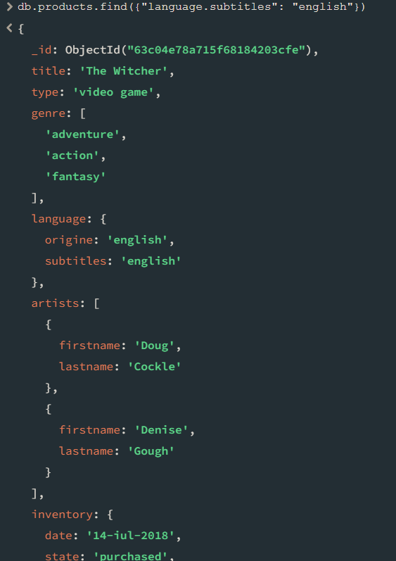

1. Cati angajati lucreaza full-time

db.employees.find({“working_hours”: ”8”}).count()

1. Cati clienti sunt din judetul cluj

db.clients.find({“address.county”: ”Cluj”}).count()

1. Afisarea produselor cumparate

1. Afisarea angajatilor care au fost angajati din 2017 pana in present

db.employees.find({“date_of_employment”: {$gt: new Date(‘01/01/2017’)}})

1. Cati angajati au salariul peste 2500

db.employees.find({“salary”: {$gt: 2500}}).count()

1. Cati angajati au peste 30 de ani

db.employees.find({“date_of_birth”: {$lt: new Date(‘01/01/1993’)}}).count()



1. Produse cu pretul peste 300

db.products.find({“inventory.price”: {$gt: 300}})

1. Produsele cumparate din 2021 pana in present

db.products.find({“inventory.date”: {$gt: new Date(‘01/01/2021’)}})

1. Salariul mediu al angajatilor care lucreaza full-time

|  |
| --- |
| db.employees.aggregate( [ |
| { |
| $match: { ”working_hours”: 8 } |
| }, |
| { |
| $group: { _id: "$job.post", avgSalary: { $avg: "$salary" } } |
| } |
|  |
| ] ) |

1. Salariul minim pe fiecare post

|  |
| --- |
| db.employees.aggregate( [ |
| { |
| $match: { ”working_hours”: {$gt: 4} } |
| }, |
| { |
| $group: { _id: "$job.post", minSalary: { $min: "$salary" } } |
| } |
|  |
|  |